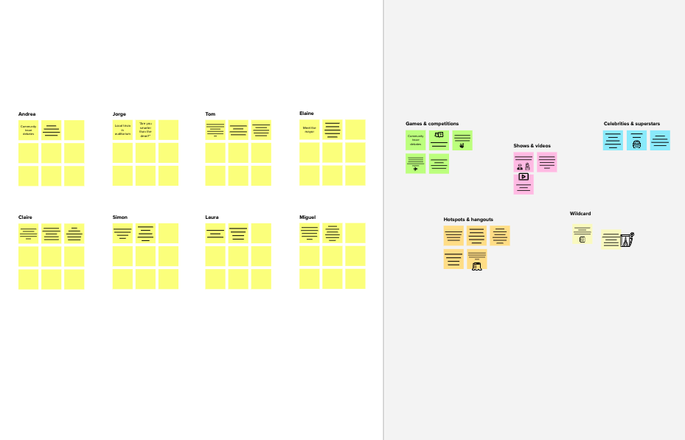

# Brainstorm

**TIP**

You can select a sticky note and hit the pencil [switch to sketch] icon to start drawing!

## Before you collaborate

A little bit of preparation goes a long way with this session. Here’s what you need to do to get going.

10 minutes

**1**

## Define your problem statement

What problem are you trying to solve? Frame your problem as a How Might We statement. This will be the focus of your brainstorm.

5 minutes

**2**

## Brainstorm

Write down any ideas that come to mind that address your problem statement.

10 minutes

**3**

## Group ideas

Take turns sharing your ideas while clustering similar or related notes as you go. Once all sticky notes have been grouped, give each cluster a sentence-like label. If a cluster is bigger than six sticky notes, try and see if you and break it up into smaller sub-groups.

20 minutes

**4**

## Prioritize

Your team should all be on the same page about what's important moving forward. Place your ideas on this grid to determine which ideas are important and which are feasible.

20 minutes

###### Pick the inventory management system that meets your unique needs

## After you collaborate

You can export the mural as an image or pdf to share with members of your company who might find it helpful.

**Quick add-ons**

# & idea prioritization

### Use this template in your own brainstorming sessions so your team can unleash their imagination and start shaping concepts even if you're not sitting in the same room.

1. **Team gathering**

Define who should participate in the session and send an invite. Share relevant information or pre-work ahead.

1. **Set the goal**

Think about the problem you'll be focusing on solving in the brainstorming session.

**Learn how to use the facilitation tools**

## PROBLEM

The problem faced by the company is they do not have any systematic system to record and keep their inventory data.

It is difficult for the admin to record the inventory data quickly and safely because they only keep it in the logbook and not properly organized.

The loss of inventory due to damage or theft can be supply chain problem.

It can account for important factors such as available space.

Inventory management controls at the warehouse and several steps.

**Sutharsan S**

Using manual inventory tracking procedures across different spreadsheets.

**Sujith M**

While keeping too little could leave you unable to fulfil customer orders.

**Siddarthan S**

One of the most common challenges to sound inventory management is preventing out.

**Stanly C**

Many online retail strategies remove the large warehouse distribution centers.

Attractive Dashboard

Managing inventory with paperwork and manual processes.

#### User Interface

Light and Dark Mode

Collect data from inventory to identify strengths and weaknesses

1. **Share the mural**

**Share a view link** to the mural with stakeholders to keep them in the loop about the outcomes of the session.

1. **Export the mural**

Export a copy of the mural as a PNG or PDF to attach to emails, include in slides, or save in your drive.

**10 minutes** to prepare

**1 hour** to collaborate

**2-8 people** recommended

Production planning is vital for avoiding delayed manufacturing and cost overruns.

Using historical and seasonal data trends can help you predict customer orders.

Planning and designing warehouse spaces with inventory.

Receiving and finding the right stock in vital to efficient positive customer experiences.

**C**

Use the Facilitation Superpowers to run a happy and productive session.

[**Open article**](https://support.mural.co/en/articles/2113740-facilitation-superpowers)

##### Key rules of brainstorming

To run an smooth and productive session

Friendly Animation and Design

All transactions and information

Hosting and deploying the

###### Keeps track of

inventory and offers a view of stock

Consider the automatic process with inventory software

Reduces the time for managing inventory

Determine a dead stock procedure

##### Keep moving forward

Create a centralized records of all products

**Strategy blueprint**

Define the components of a new idea or strategy.

[**Open the template**](https://app.mural.co/template/e95f612a-f72a-4772-bc48-545aaa04e0c9/984865a6-0a96-4472-a48d-47639307b3ca)

**Customer experience journey map**

Stay in topic. Defer judgment.

Encourage wild ideas. Listen to others.

transfers must be encrypted.

#### Security

application on the IBM Cloud

##### Importance

Identify stock location in inventory

If each of these

Understand customer needs, motivations, and

obstacles for an experience.

[**Open the template**](https://app.mural.co/template/b7114010-3a67-4d63-a51d-6f2cedc9633f/c1b465ab-57af-4624-8faf-ebb312edc0eb)

Go for volume. If possible, be visual.

tasks could get

done without any difficulty or cost, which would have the most positive impact?

Login using their personal account's

**Strengths, weaknesses, opportunities & threats**

Identify strengths, weaknesses, opportunities, and threats (SWOT) to develop a plan.

Do regulate and accurate stock counts

Create a purchasing process

Establish a method for markdowns

[**Open the template**](https://app.mural.co/template/6a062671-89ee-4b76-9409-2603d8b098be/ca270343-1d54-4952-9d8c-fbc303ffd0f2)

[**Share template feedback**](https://muralco.typeform.com/to/CiqaHVat?typeform-source=app.mural.co)

Build a stock receiving process

### Retail inventory management

Pick your inventory KPIs

Combine sales and inventory data

Create a system for returns

[**Share template feedback**](https://muralco.typeform.com/to/CiqaHVat?typeform-source=app.mural.co)

##### Feasibility

Regardless of their importance, which tasks are more feasible than others? (Cost, time, effort, complexity, etc.)

**Template**

**Need some inspiration?**

See a finished version of this template to kickstart your work.

[**Open example**](https://app.mural.co/template/e5a93b7b-49f2-48c9-afd7-a635d860eba6/93f1b98d-b2d2-4695-8e85-7e9c0d2fd9b9)